Difference between website and webapplication

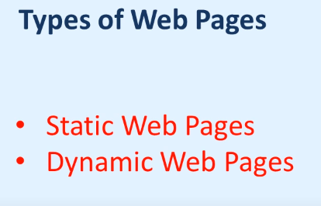

Static website --🡪 Static page e tamon kono change hoi na like contact info, service page, about section eigula tamon kono change hoi na static web page e. bivinnow company website othoba onnow kono page build kora hoi. Static web page er jonoow tamon besi khoroch hoi na.

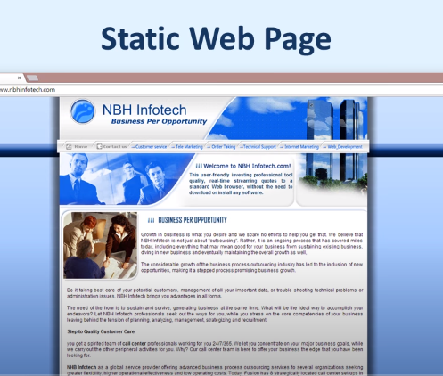

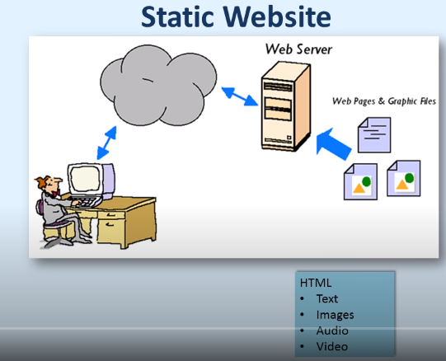

Dynamic website--🡪eikhanay sob kiso ekoi rokom thakay na like structure create kora hoyesay kinto ekoi structure bivinnow structure asbay like ekoi structure e sobar ei student info thakbay.

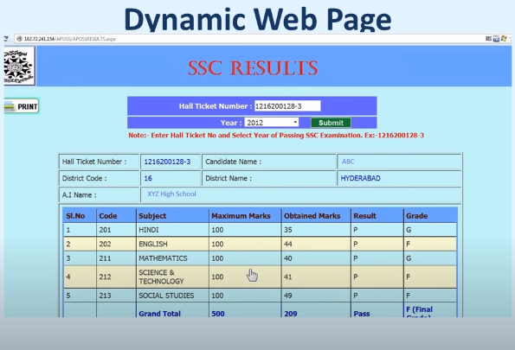 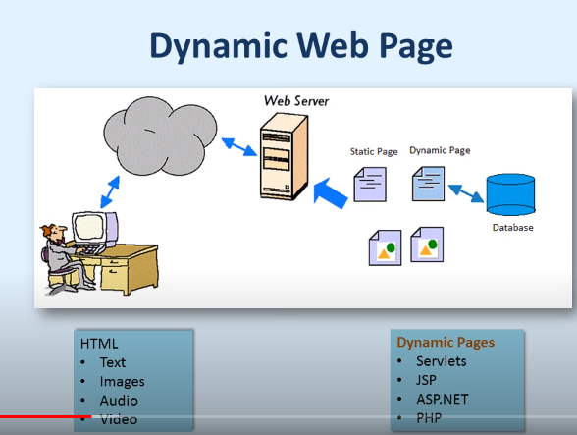

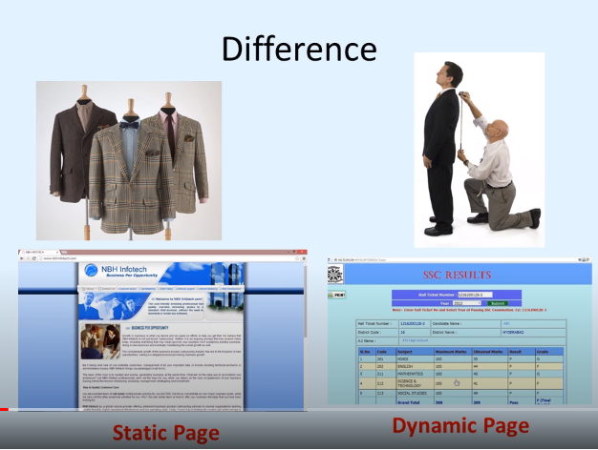

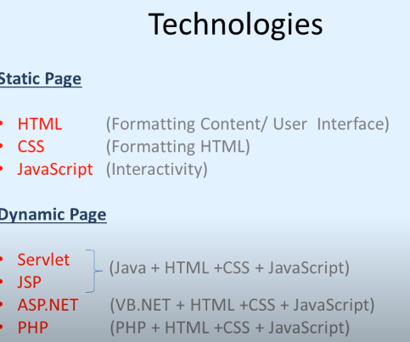

Web application ----- > like ami ekta application create koraysi jekhanay continuously data change hoi like facebook, twitter eigula holo web application jekhanay actually continuously data change hoi data update hotay thakay eikhanay data gula cloud thekay assay. World er all place thekay web application e join kora jai ebong user er chahida moto data peye thakay. Beside news paper jekhany protinioto new message assay tai eti holo web application abar Jodi kono bloging site thakay jekhan thekay new article publish koray taholaw etiow holo webapplication.

Ekhon amora je Microsoft office use koray thaki etio ekti holo web application beside Microsoft 365 jeti cloud e data rakhay jekhan thekay khusi join kora jai eti o ekti web application. So it is called a cloud base application.

